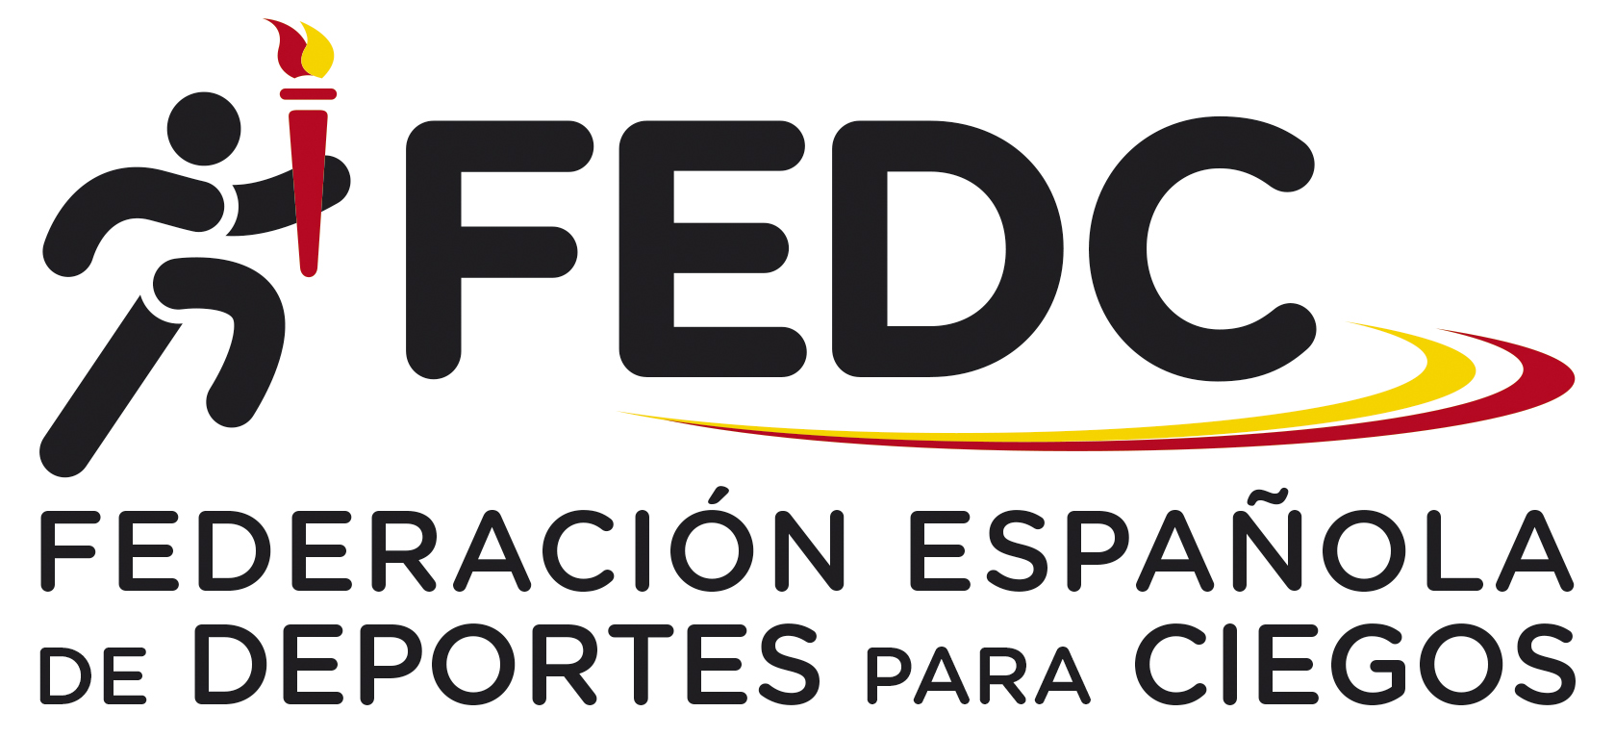

”FEDC International Goalball Tournament 2024”

organized by the Spanish Federation of Sports for the Blinds (FEDC)

Dear Friends,

the Spanish Federation of Sports for the Blinds (FEDC) is pleased to invite you to the “FEDC International Goalball Tournament 2024”, for six male and six female national teams.

Arrival: 31th October, Thursday, if is possible after 15:00 hours. The closest airport is: Madrid ”Adolfo Suarez –Barajas” Airport.

Competition: 1st to 3rd November, Friday to Sunday.

Prize - giving ceremony: 3rd November, Sunday, straight after the competition in the Sports Hall.

Departure: 3rd November, Sunday, after lunch (if is possible not before 16:00 hours).

Sports Venue: The competition will take place at ONCE School for the Blinds, in Madrid ( at 15 minutes from the airport). The sports hall has synthetic surface.

Rules: The competition will be carried out in accordance with IBSA goalball rules (2022-2024 period).

Accommodation: Delegations will be accommodated at the same ONCE School for the Blinds.

Transportation: We will be able to provide teams with the transportation from Madrid airport to the School and back.

Entry fee and payment: the entry fee is 270 € per person including accommodation and board from Thursday’s dinner to Sunday’s lunch.

For those who are coming earlier or leave Madrid later, the following prices will be charged: 90 € per person and day.

If you have interest to take part, please send us your First Entry Form before 5th July by mail.

The entry fee must be paid before 27th September by bank transfer at the following account:

Name: Federación Española de Deportes para Ciegos (FEDC)
Bank: Banco Santander
Adress: Avda. Burgos 8, Bajo Dcha. Madrid
28036 Madrid (Spain)
IBAN Code Account number: ES0400496093062516201767
SWIFT Code : BSCHESMMXXX
Reference: FEDC Tournament 2024 (Country and category)

Should you require any further information, please don´t hesitate to contact at the following e-mail adress:
fmov@once.es

Thank you!

”FEDC International Goalball Tournament 2024”

organized by the Spanish Federation of Sports for the Blinds (FEDC)

FIRST ENTRY FORM

Please complete this form and send it to the following addresses, no later than 5th July 2024.

Address:

FEDC

Paseo de la Habana 208

28036 Madrid (Spain)
E-mail: fmov@once.es

Team:

Category (M/F):

Number of Players:

Number of Staff:

Contact person:

Address or e-mail of contact person:

”FEDC International Goalball Tournament 2024”

organized by the Spanish Federation of Sports for the Blinds (FEDC)

SECOND ENTRY FORM

Please complete this form and e-mail or send it to the following addresses, no later than 27th September 2024, with the confirmation of payment.

Address:

FEDC

Paseo de la Habana 208

28036 Madrid (Spain)
E-mail: fmov@once.es

Team:

Date and time of arrival:

Date and time of departure:

Team Composition
Function | Name | Jersey Number

