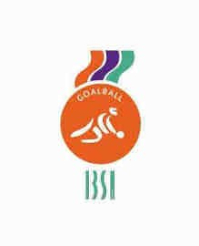
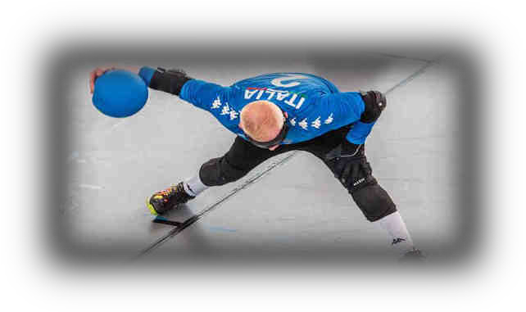

IBSA Goalball B European Championships

30 May - 05 June 2024

Information and Entry Forms for Teams

for Women’s Team

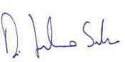

Welcome Message

Dear sports friends,
I have the honor and pleasure of welcoming you to Lignano Sabbiadoro, where the IBSA Blind Goalball B European Championships will take place.
It is with great pride that the whole federal movement I represent organizes an International Paralympic competition of Goalball in Italy.
We are working together with all the staff for the realization of an event which will give strong visibility to the discipline, reinforcing its image and identity, and to all the Paralympic movement, and at the same time convey the history, culture, and traditions of the hosting Country.
I look forward to seeing you in Italy, taking part in this important sporting event,

Sandro Di Girolamo
FISPIC President

2024 IBSA Goalball B European Championships

Dates and Contacts

The 2024 IBSA Goalball B Women’s European Championships will be held in Lignano Sabbiadoro (UD), from Monday 30.05.2024 to Tuesday 05.06.2024, with matches taking place from the 1st to the 4th of June.

The headquarter of the Organization Committee is the Italian Blind Sport Federation (FISPIC): LOC address: Piazzale degli Archivi 40-42 – 00144, Rome, Italy
Website: www.fispic.it

Main contact person for teams:
Name: Renato Tomei
E-Mail: europeangoalball24@gmail.com

Travel Information

  - Travel to/from/in Lignano Sabbiadoro

Airports
- Venezia Marco Polo (VCE): 95 km from Lignano Sabbiadoro (1.15h)
- Trieste Ronchi dei Legionari: 65 km from Lignano Sabbiadoro (1h)

Railway Stations
- Venezia Mestre (VE)
- Latisana (UD)

Transportation between the above-mentioned airports/railway stations and the competition venue/hotel will be provided to all accredited delegation members, from the official arrival day to the official departure day.
National teams must provide information on travel arrangements. Pickup at airport/ railway station can only be guaranteed if the travel details are provided by the dates requested on the booking form.

Passport and Visas
EU citizens may enter Italy with a valid travel document (identity card or passport), without the need to apply for a visa.
Non-EU citizens need a valid passport and a visa for entering Italy.

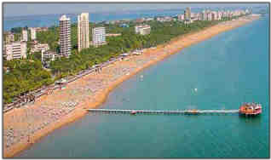
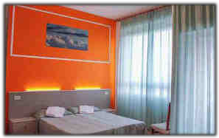
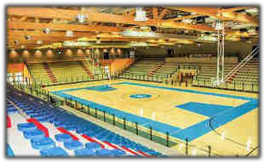
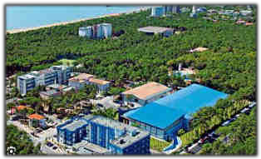

Regulations regarding Guide Dogs
If a national team wishes to be accompanied by a guide dog, please contact the organization at europeangoalball24@gmail.com

Accommodation and the Competition Venue

National teams, officials, referees, classifiers, and other invited participants will be staying at the Bella Italia Efa Village Sport & family - Viale Centrale, 29, 33054 Lignano Sabbiadoro UD https://www.bellaitaliavillage.com/

The Bella Italia Efa Village Sport & Family, will be the official Hotel for the Championships (for accredited members only), and also the competition venue.
The hotel offers several services, including a private beach, a Water park, a swimming pool, and numerous sports facilities (football, tennis, showdown, goalball, judo, basket, volleyball, fitness etc.).

Catering

Accredited members will be served breakfast, lunch and dinner at the EFA Village during the Championships, starting with the dinner of the 30.05.2024 and ending with the breakfast of the 05.06.2024.
The meals will be served at the following times:

•Breakfast 06:00 – 09:00
• Lunch 11:30 – 15:30
• Dinner 19:00 – 21:00
Breakfast and lunch are buffet style while dinner is table service.
Variations may occur according to the final program of the matches.
There will be a vegetarian option at all meals. Gluten-free and other special dietary meals are available on request.

Entry fees

Entry fee: 150,00 € per night per person
- Deposit (50%) to be paid by 29 February 2024
- Balance to be paid by 20 April 2024

The fee covers:
- double room accommodation
- Transfers from/to airport/railway station
• Meals (dinner 30.05.2024 – breakfast 05.06.2024)
- Private beach access (n.1 umbrella and n. 2 beach beds for each room)
- Free Hotel parking
- For accommodation in single room, the supplement is € 30,00 per night per person,
according to the rooms’ availability

Additional costs:
- IBSA capitation tax € 25,00 per athlete;
- IBSA Anti-doping Fee € 50,00 per athlete;
- Optional payment for extra nights or additional group members, as specified in Forms 2/3;
- Additional costs associated with arrival/departure from airports/railways stations not mentioned in section 2;
- Other expenses may be applied on arrival, depending on team requirements. These may include additional water (the venue will provide free water only for matches), snacks, recreational activities etc.

Payment:
Payment must always be in Euro (€).
Please note that you are responsible for paying all bank charges, including transfer fees.

Entry forms deadlines

Form | Description | Deadline
1. | Expression of Interest (entry by number) | 29 February
2. | Finance – 50 % deposit | 29 February
3. | Finance – balance of payment and IBSA capitation tax | 20 April
4. | Team profile and dietary requirements | 20 April
5. | Arrival/departure details | 20 April
6. | Delegation Form (entry by name) | 20 April

- The Competition

  - Competition Schedule

- Arrival of the teams: 30 May 2024
- Classification Period: 31 May 2024
- Opening Ceremony: 31 May 203
- Opening Game: 1 June 2023
- Competition Period: 1 – 4 June 2023
- Closing Ceremony: 4 June 2023
- Departure: 5 June 2023

The detailed schedule can be found as Appendix 1 “Competition Schedule” at the end of this document.

Training
Prior to the event, team training sessions will be organized using the second indoor pitch, located at the EFA Village.

Changing Rooms
Changing rooms will be available for all teams inside the venue. Showers and toilets are located inside the changing rooms.

Referees and Rules
Referees will be official IBSA referees and all matches shall be played according to the current IBSA Goalball regulations.

Anti-Doping and Medical

  - Anti-Doping Control
The event is subject to random doping tests in accordance with IBSA regulations. Athletes should refer to the IBSA Anti-Doping Policy.
Any athlete taking medication subject to doping controls must be in possession of a valid IBSA Therapeutic Use Exemption (TUE). For information on IBSA’s anti-doping policies and how to apply for a TUE, go to www.ibsasport.org/anti-doping.

Classification
Classification process will respect IBSA procedure, as defined by IBSA Classification rules, http://www.ibsasport.org/documents/files/182-1-IBSA-Classification-rules-2018.pdf.
Only athletes competing in this event can be classified. All athletes must be licensed for the current year.

Procedure for the classification of an athlete at a competition:
    - A fully filled MDF, dated and signed by a certified ophthalmologist, must be uploaded in ISAS by 20 APRIL 2024. Only the current MDF (available for downloading from the IBSA website) is accepted.
http://www.ibsasport.org/documents/files/179-1-IBSA-Medical-Diagnostics-Form.pdf
    - For athletes with a Review status - tests and complementary medical exams requested in previous competitions should be uploaded at the same time of MDF - 6 weeks prior to the competition - 20 APRIL 2024. Every athlete should state in the MDF if they wear optical correction (glasses, contact lenses, filters) when they compete.
    - Athletes without the correct MDF uploaded in due time will not be scheduled for classification and cannot enter the competition. There will be no exceptions.

Medical Service
Teams who do not have their own team doctor will be able to take advantage of the event medical assistance. The medical assistance will operate daily during the competition time.

Insurance
Participating members are responsible for their own insurance requirements for travel, personal accident, liability, and medical matters.

Other information

  - Athletes' Eligibility
All the athletes must be licensed for the current year (2024), have a valid eye classification, and belong to an IBSA Member in good standing.

Online registration with IBSA ISAS Database
Team athlete entries should be made using the ISAS Online Registration System: https://isas.ibsasport.org/isas/entries/index

Athletes' Substitution
Substitution (because of injuries, visa problems or all other reasons) of an athlete will only be allowed up to the deadline of the MDF upload. After that date NO substitutes will be allowed to participate.

Appendix 1 – General Schedule

 | 30 | 31 | 1 | 2 | 3 | 4 | 5
Arrival
Classifications
Opening Ceremony
Opening Game
Games
Semifinals
Finals
Departure

