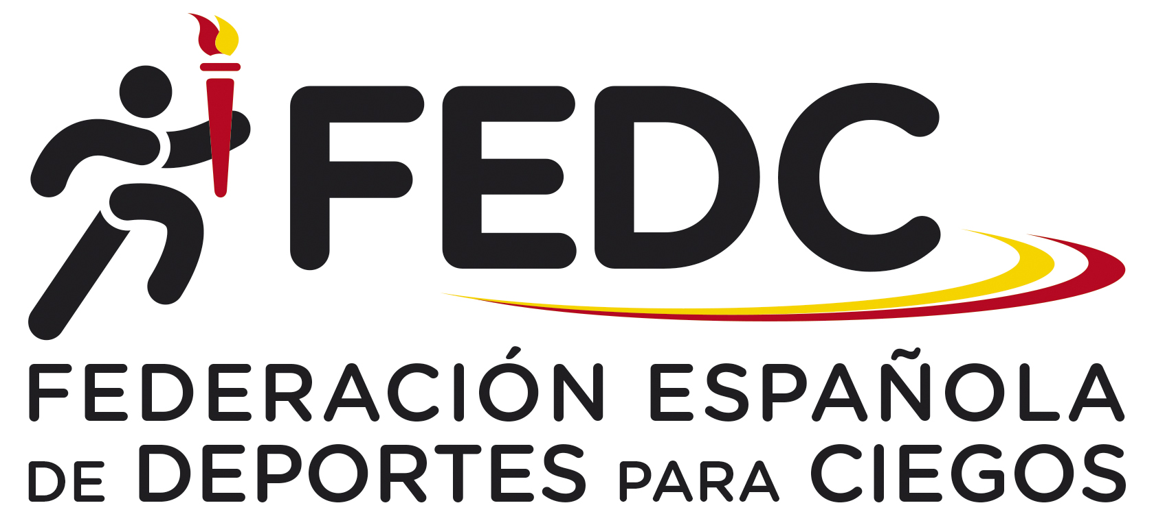

”FEDC International Goalball Female Tournament 2023”

organized by the Spanish Federation of Sports for the Blinds (FEDC)

Dear Friends,

the Spanish Federation of Sports for the Blinds (FEDC) is pleased to invite you to the “FEDC International Goalball Female Tournament 2023”, for a maximum of six teams (including the home team Spain).

Arrival: 3rd November, Friday, if is possible after 15:00 hours. The closest airport is: Madrid ”Adolfo Suarez –Barajas” Airport.

Competition: 4th and 5th November, Saturday and Sunday.

Prize - giving ceremony: 5th November, Sunday, straight after the competition in the Sports Hall.

Departure: 5th July, Sunday, after lunch (if is possible not before 16:00 hours).

Sports Venue: The competition will take place at ”La Granadilla” Sports Hall, in Majadahonda (Madrid). The sports hall has synthetic surface.

Rules: The competition will be carried out in accordance with IBSA goalball rules (2022-2024 period).

Accommodation: Delegations will be accommodated in a Hotel near to the Sports Hall.

Transportation: We will be able to provide teams with the transportation from Madrid airport to the Venue and Hotel and back.

Entry fee and payment: the entry fee is 180 € per person including accommodation in double or triple rooms and board from Friday’s dinner to Sunday’s lunch. Single rooms will be available for an extra 40 € per person, for whole period.

For those who are coming earlier or leave Madrid later, the following prices will be charged: 90 € per person and day in double room (or 110 € in single room).

**If you have interest to take part, please send us your First Entry Form before 19th September by mail.**

The entry fee must be paid before 23rd October by bank transfer at the following account:

Name: Federación Española de Deportes para Ciegos (FEDC)

Bank: Banco Santander

Adress: Avda. Burgos 8, Bajo Dcha. Madrid

28036 Madrid (Spain)

IBAN Code Account number: ES0400496093062516201767

SWIFT Code : BSCHESMMXXX

Reference: FEDC International Goalball Female Tournament 2023 (Country)

Should you require any further information, please don´t hesitate to contact at the following e-mail adress:

[fedc@once.es](mailto:fedc@once.es) or [fmov@once.es](mailto:fmov@once.es)

Thank you!



”FEDC International Goalball Female Tournament 2023”

organized by the Spanish Federation of Sports for the Blinds (FEDC)

**FIRST ENTRY FORM**

# Please complete this form and send it to the following addresses, no later than 19th September 2023.

# Address:

# FEDC

# Camino de Hormigueras 172

# 28031 Madrid (Spain)

E-mail: [fedc@once.es](mailto:fedc@once.es) or [fmov@once.es](mailto:fmov@once.es)

Team:

Number of Players:

Number of Staff:

Contact person:

Address or e-mail of contact person:



” FEDC International Goalball Female Tournament 2023”

organized by the Spanish Federation of Sports for the Blinds (FEDC)

**SECOND ENTRY FORM**

# Please complete this form and e-mail or send it to the following addresses, no later than 23rd October 2023, with the confirmation of payment.

# Address:

# FEDC

# Camino de Hormigueras 172

# 28031 Madrid (Spain)

E-mail: [fedc@once.es](mailto:fedc@once.es) or [fmov@once.es](mailto:fmov@once.es)

Team:

Date and time of arrival:

Date and time of departure:

**Team Composition**

|  |  |  |
| --- | --- | --- |
| **Function** | **Name** | **Jersey Number** |
|  |  |  |
|  |  |  |
|  |  |  |
|  |  |  |
|  |  |  |
|  |  |  |
|  |  |  |
|  |  |  |