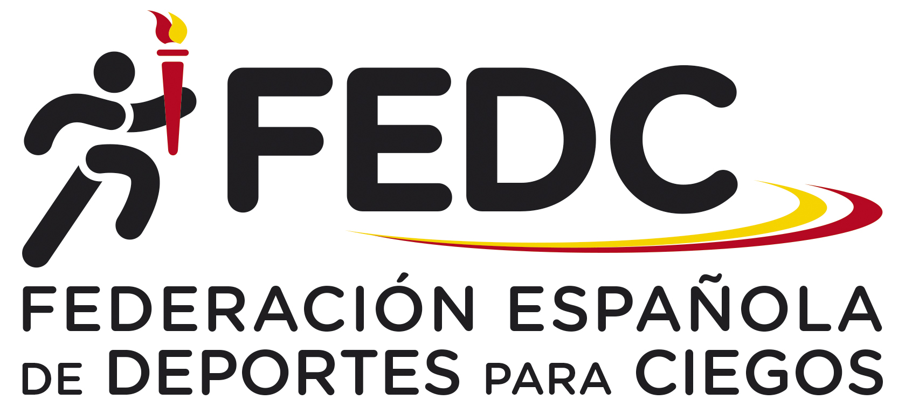

”FEDC International Goalball Male Tournament 2023”

organized by the Spanish Federation of Sports for the Blinds (FEDC)

Dear Friends,

the Spanish Federation of Sports for the Blinds (FEDC) is pleased to invite you to the “FEDC International Goalball Male Tournament 2023”, for a maximum of six teams (including the home team Spain). We will prior the teams of European C 2023.

Arrival: 7th July, Friday, if is possible after 15:00 hours. The closest airport is: Madrid ”Adolfo Suarez –Barajas” Airport.

Competition: 8th and 9th July, Saturday and Sunday.

Prize - giving ceremony: 9th July, Sunday, straight after the competition in the Sports Hall.

Departure: 9th July, Sunday, after lunch (if is possible not before 16:00 hours).

Sports Venue: The competition will take place at ONCE Educational Resource Center, in Madrid ( at 15 minutes from the airport). The sports hall has synthetic surface.

Rules: The competition will be carried out in accordance with IBSA goalball rules (2022-2024 period).

Accommodation: Delegations will be accommodated at ONCE Educational Resource Center, in Madrid, the same place of the Sports Hall.

Transportation: We will be able to provide teams with the transportation from Madrid airport to the Venue and back.

Entry fee and payment: the entry fee is 140 € per person including accommodation in double or triple rooms and board from Friday’s dinner to Sunday’s lunch.

For those who are coming earlier or leave Madrid later, the following prices will be charged: 70 € per person and day.

If you have interest to take part, please send us your First Entry Form before 19th May by mail.

The entry fee must be paid before 23rd June by bank transfer at the following account:

Name: Federación Española de Deportes para Ciegos (FEDC)
Bank: Banco Santander
Adress: Avda. Burgos 8, Bajo Dcha. Madrid
28036 Madrid (Spain)
IBAN Code Account number: ES0400496093062516201767
SWIFT Code : BSCHESMMXXX
Reference: FEDC International Goalball Male Tournament 2023 (Country)

Should you require any further information, please don´t hesitate to contact at the following e-mail adress:
fedc@once.es or fmov@once.es or pacomonreal@hotmail.com

Thank you!

”FEDC International Goalball Male Tournament 2023”

organized by the Spanish Federation of Sports for the Blinds (FEDC)

FIRST ENTRY FORM

Please complete this form and send it to the following addresses, no later than 19th May 2023.

Address:

FEDC

Paseo de la Habana 208

28036 Madrid (Spain)
E-mail: fedc@once.es or fmov@once.es or pacomonreal@hotmail.com

Team:

Number of Players:

Number of Staff:

Contact person:

Address or e-mail of contact person:

”FEDC International Goalball Tournament 2022”

organized by the Spanish Federation of Sports for the Blinds (FEDC)

SECOND ENTRY FORM

Please complete this form and e-mail or send it to the following addresses, no later than 23rd June 2023, with the confirmation of payment.

Address:

FEDC

Paseo de la Habana 208

28036 Madrid (Spain)
E-mail: fedc@once.es or fmov@once.es or pacomonreal@hotmail.com

Team:

Date and time of arrival:

Date and time of departure:

Team Composition
Function | Name | Jersey Number

