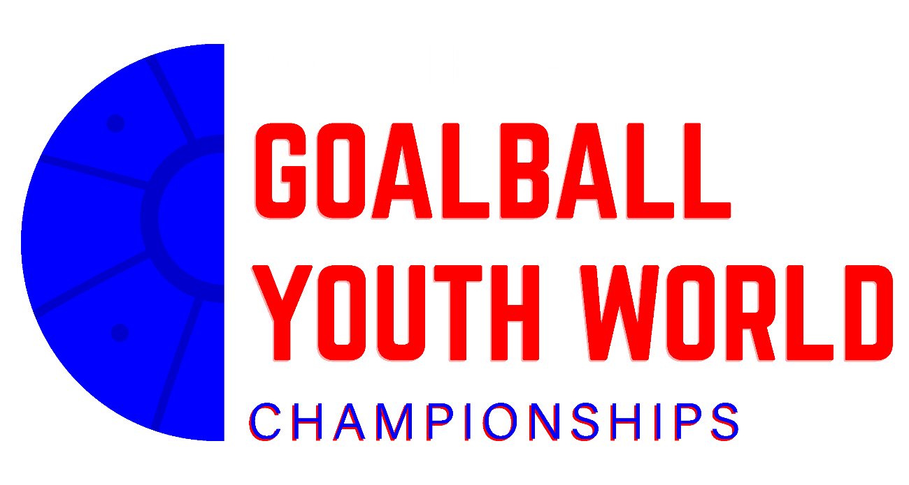

OFFICIAL INVITATION
2023 IBSA Goalball Youth World Championships

January 31, 2023.

Dear IBSA Member,

The Brazilian Confederation of Sports for the Visually Impaired (CBDV) invites your national team to attend the “2023 IBSA Goalball Youth World Championships to be held in São Paulo, Brazil from the 12th to the 19th of july 2023.

Organization

CBDV – Brazilian Confederation of Sports for the Visually Impaired.

Programme of the Competition

DATE | TIME | ACTIVITY | PLACE
12 july | All day | Arrival of Delegations and Accreditation | AIRPORT/BPC
13 july | 9am – 5pm | Sight Classification | BPC
 | 9am – 7pm | Training Sessions | BPC
14 july | 9am – 5pm | Classifications | BPC
 | 8am – 2pm | Training Sessions | BPC
 | 6pm | Technical Meeting | BPC
15 july | 8am | Opening Ceremony | BPC
 | 8:30am – 8pm | Competition | BPC
16 july | 8am – 8pm | Competition | BPC
17 july | 8am – 8pm | Competition | BPC
18 july | 8am – 8pm | Competition | BPC
19 july | 8am – 1pm | Finals | BPC
 | 1:30pm | Closing Ceremony | BPC
 | After – 3pm | Departures | BPC

CLASSIFICATION
Procedure for the classification of an athlete at a competition:
• A fully filled MDF, dated and signed by a certified ophthalmologist, must be uploaded in ISAS –- until 31 May 2023 - 6 weeks before the first classification day of the event. Only the current MDF (available for downloading from the IBSA website is accepted).
http://www.ibsasport.org/documents/files/179-1-IBSA-Medical-DiagnosticsForm.pdf

The MDF’s will be thoroughly checked after they have been uploaded. Athletes without the correct MDF uploaded in due time will not be scheduled for classification and can not enter the competition. There will be no exceptions.

• For athletes with a Review status - tests and complementary medical exams requested in previous competitions should be uploaded at the same time of MDF - 6 weeks - BY 31 May 2023. If not, the athlete will be excluded from the competition.

Every athlete should state in the MDF if they wear optical correction (glasses, contact lenses, filters) when they compete. If so and it was not STATED in the MDF form the athlete will be excluded from the competition.

• All athletes to be classified at an event need to be ready for classification at the first hour on the first day and rested especially if the travel has been long distance. Sleepy/tired people cannot cooperate well and they risk not to be classified. Late arrivals will not be considered for the Classification schedules.
• Only athletes competing in this event can be classified
• Athletes may be subject to controls during any competition. In the case of an athlete found during the competition, to be wearing contact lenses which were not declared during classification, he or she will be subject to disqualification.

ATHLETES' ELIGIBILITY
Please note that all athletes must comply with the following conditions before being accredited to the event:

- IBSA Athletes License for the current year
- Athletes must be no older than 19 as of 31 December 2023 ;
- Paid IBSA Membership fee for the current year;
- Athletes must have a vision classification on file that makes them eligible to compete during the period of the competiton or must have a Medical Diagnostics Form (and any required supporting documentation on file) in the IBSA Sports Administration System that is less than one year old.

Competition Venue

Brazilian Paralympic Training Center
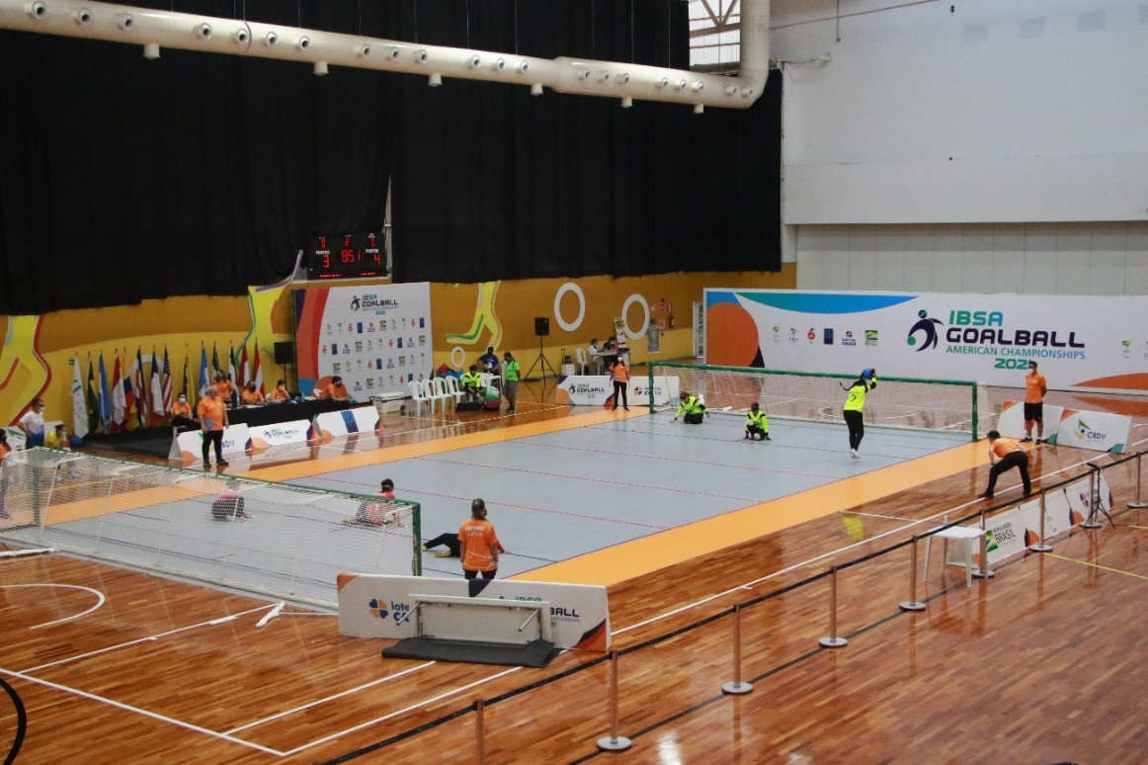

PARTICIPANTS

Maximum 8 teams it the men´s category
Maximum 8 teams it the women´s category

Entries will be processed in the order received and any teams beyond the 8 team maximum will be placed on a waiting list to fill vacancies that occur

Deadlines

1st entry form (competitors Numerical Inscription) – April 30, 2023.
2nd entry form (Final nominal entry) – June 1, 2023.
- It is mandatory to fill the form with full name, passport number, Telephone and home address.
3rd entry form (Travel Schedule) – July 1, 2023.
Deadline for Payment: July 1, 2023.

ATTENTION: Applications submitted after the deadline stipulated by the LOC will not be accepted.

Registration (forms)

Ana Deise – Anadeise@cbdv.org.br
Tel: +55 11 2548 0463
General Informations: Felipe Menescal – felipemenescal@cbdv.org.br

ONLINE REGISTRATION SYSTEM
All entries for the 2023 IBSA Goalball Youth World Championships should be made by the ISAS Online Registration System

Price per Person:

- 700 USD per person (the invoice will be sent after receiving the 2nd entry form) – Full board + Accommodation + Local Transportation

- 15 € IBSA Capitation Fee should be also paid for each athlete to the LOC. IBSA will then invoice the LOC accordingly.

- The payment of the registration fee must be done until July 1, 2023.

Meals
12 july | Only Dinner Included
13 july | Full board
14 july | Full board
15 july | Full board
16 july | Full board
17 july | Full board
18 july | Full board
19 july | Only Breakfast and Lunch Included

Accomodation
Check in – 12th July - after 1pm
Check out – 19th July

Local transportation
12th July | Airport x BPC
19th July | BPC x Airport

AIRPORT

Guarulhos International Airport

40km – Brazilian Paralympic Training Center

Congonhas National Airport

8,5km - Brazilian Paralympic Training Center

HOTEL

Brazilian Paralympic Center

All participants will stay at the hotel of the Brazilian Paralympic Training Center.
Room for two, four and six people

The division of the rooms will be done by the organizing committe.

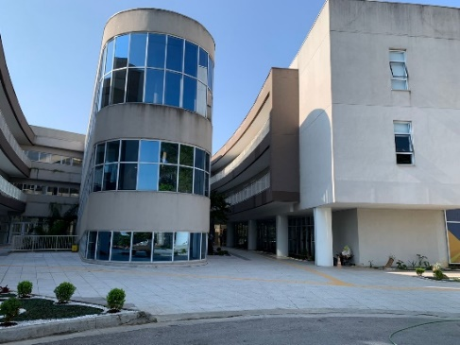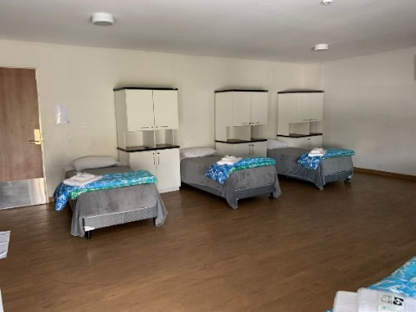
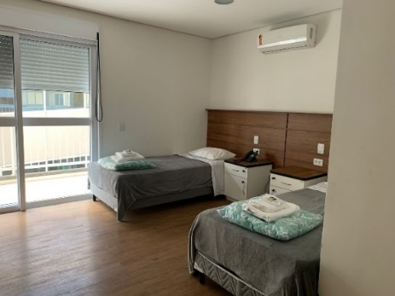

CBDV – LOC “2023 IBSA GOALBALL YOUTH WORLD CHAMPIONSHIPS”

