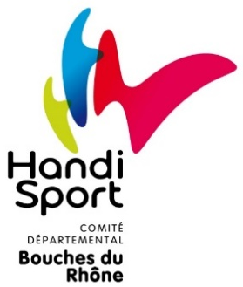
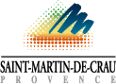

MEN’S INTERNATIONAL GOALBALL TOURNAMENT FRANCE – 2023

FIRST ENTRY FORM

Complete this form and send by email at cd13@handisport.org, no later than June 30th, 2023. Remember to attach the bank receipt of the first payment of 500 €.

TEAM:

COUNTRY:

NUMBER OF PLAYER:

NUMBER OF STAFF:

NUMBER OF ROOM: Triple: ___. Double: ___. Single (Extra): ___

EXTRA NIGHT: Thursday (yes or no): ___ Sunday (Yes or no): ___

CONTACT PERSON:

E-MAIL:

PHONE NUMBER:

POSTAL ADDRESS:

OTHER CONTACT DETAILS FOR COMMUNICATION:

COMMENTS:
BANK TRANSFER : IBAN FR76 3000 3012 5100 0372 6279 349

