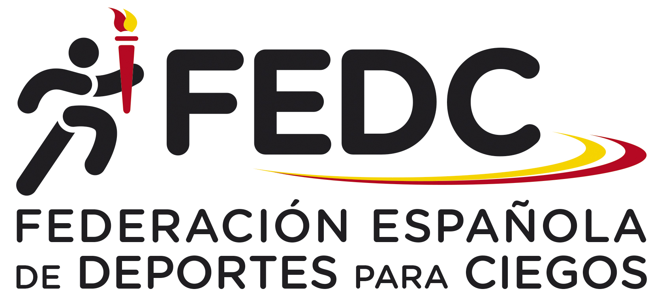

GOALBALL REFEREE’S CLINIC

”FEDC International Goalball Tournament 2022”

organized by the Spanish Blind Sports Federation (FEDC)

Dear Friends,
the Spanish Blind Sports Federation (FEDC) is pleased to invite you to the Goalball Referee’s Clinic, levels 1 to 3, in conjunction with the “FEDC International Goalball Tournament 2022”, for Male and Female National Teams.

We can accept 6 foreign referees on the ‘first-come, first-served’ basis

Arrival: 12th October, Wednesday, if is possible after 15:00 hours.

Clinic: 13th October, Thursday, to 16th October, Sunday (14:00 hours).

Departure: 16th October, Sunday, after lunch (not before 15:00 hours).

Clinic Conductor: Aurora Zanolin, from Italy.

Sports Venue: The clinic and the competition will take place at ONCE Cultural and Sports Complex (former ONCE School for the Blinds), in Madrid ( at 15 minutes from the airport and 700 metres from the Hotel).

Accommodation: Referees and Teams will be accommodated at the Hotel ILUNION PIO XII, (4 stars category), situated very close to the venue.

Clinic Entry Fee: the entry fee is 250 € per person, including accommodation and full board from Wednesday’s dinner to Sunday’s lunch, and transport from Madrid airport to the hotel and back. From Hotel to Venue, will go walking by themselves.

After the confirmation of your entry, you’ll must pay the entry fee by cash when you’ll arrive to the Hotel on Wednesday 12th October.

Should you require any further information, please don´t hesitate to contact at the following e-mail adress:
fmov@once.es or pacomonreal@hotmail.com

Thank you!

ENTRY FORM

Please complete this form and e-mail or send it to the following addresses, fmov@once.es or pacomonreal@hotmail.com

Name:

Country:

e-mail of contact person:

Current IBSA Goalball Referee Level:

In this Clinic, you want to participate in level : 1 / 2 / 3

Date and time of arrival:

Date and time of departure:

