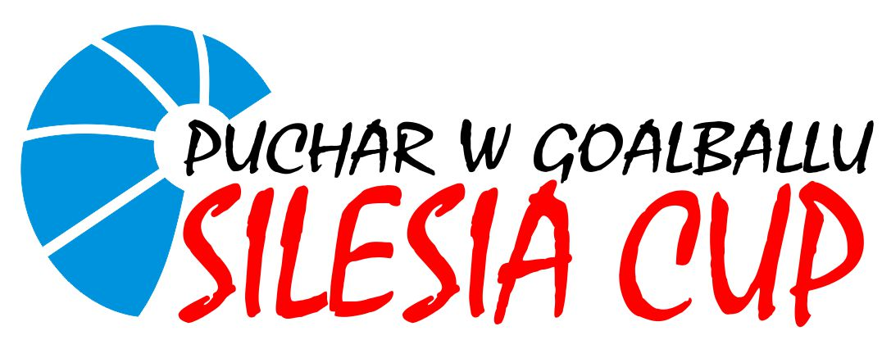

XIV GOALBALL TOURNAMENT SILESIA CUP

Arrival: September 11th 2025 (Thursday)
Competition: September 12th-14th 2025
Departure: September 14th 2025 (Sunday) (Flight from Katowice earliest at. 3.00 PM)

Competition: For 8 male and 4 female (ONLY NATIONAL TEAMS).
Sports venue: K.S. HAJDUKI in Chorzow, Graniczna 92 Street.
Accommodation: Hotel Focus in Chorzow, Armii Krajowej 15 Street.
Rules: The competition will be carried out in accordance with IBSA goalball rules 2025.

Entry fee: the entry fee is 250 € per person, including accommodation and full board from Thursday’s dinner to Sunday’s lunch, and transport from Katowice-Pyrzowice airport to the hotel and return.

Deadline: After the confirmation of your entry, you’ll must pay the entry fee before July 31st 2025 by bank transfer at the following account:

Name: Wojewódzkie Stowarzyszenie Sportu i Rehabilitacji Niepełnosprawnych START
Bank: Bank PEKAO SA o/Katowice
Adress: 40-121 Katowice, ul. Chorzowska 1
IBAN Code: PL 59 1240 1330 1978 0011 3048 0283
SWIFT Code: PKOPPLPW
Transfer title: Silesia Cup Goalball 2025 - Country

Should you require any further information, please don´t hesitate to contact at the following e-mail adress: startkatowice@poczta.onet.pl

Thank you!

FIRST ENTRY FORM

Country
Name of a team
Natonial | Club
Men / Women
Number of players |  | Male
 |  | Female
Number of staff |  | Male
 |  | Female
Special diet
Do you need any single rooms? (regular participation fee includes double or triple rooms)
Do you need a ground transportation to/from airport/station – goalball venue?
Total number in delegation

Please complete this form and send an email to startkatowice@poczta.onet.pl before April 30th 2025.

SECOND ENTRY FORM

Please complete this form and send an email to startkatowice@poczta.onet.pl July 31st 2025

Team:
Sex category:
Time of arrival:
Time of departure:

Team:

Name | Function | Jersey Number

